

SCHOOL OF ADVANCED TECHNOLOGY
SAT301 FINAL YEAR PROJECT

PCB Defect Detection Based on YOLO Utilizing Transfer Learning

Final Thesis

In Partial Fulfillment
of the Requirements for the Degree of
Bachelor of Science

Student Name | : | Jiajun.Zhu
Student ID | : | 2252531
Supervisor | : | Dechang.Xu
Assessor | : | Pengfei Song

Abstract
This paper mainly focuses on the application of a well-known model in the field of computer vision, namely YOLO, for the automatic detection of surface defects on PCBs. Given the limited scale of high-quality PCB data, this paper attempts to utilize transfer learning to enhance the accuracy of defect detection in small data samples, and employs BiFPN and Attention mechanisms to improve the model performance.

Keywords: PCB;Defect Detection;YOLO;Transfer Learning;BiFPN

Acknowledgements
At this point, my undergraduate studies are coming to a conclusion. I would like to express my gratitude to all the teachers who have provided guidance and support throughout the journey, as well as to my family and friends for their kind-hearted encouragement. In the future, I will continue to maintain an attitude of proactive progress and keep moving forward.Regarding the FYP thesis, I would like to express my sincere gratitude to Professor Xu for his meticulous guidance. Moreover, I am extremely grateful to my DA, Teacher Li, for his assistance in the aspect of job placement. I really appreciate all of you for your kindness.

Contents
Abstract .................................................................................... ii
Acknowledgements ................................................................. ii
Contents (This is an example) ............................................... iii
List of Tables ............................................................................ iv
List of Figures .......................................................................... v
List of Acronyms ..................................................................... vi
Chapter 1 Introduction ............................................................ 1
1.1 Motivation, Aims and Objective ....................................... 1
1.2 Literature Review .............................................................. 3
Chapter 2 Methodology and Results ....................................... 8
2.1 Methodology ..................................................................... 8
2.1.1 Data Preparation.............................................................8
2.1.2 YOLO v8 ....................................................................... 12
2.1.3 Transfer Learning ............................................................16
2.1.4 Bidirectional Feature Pyramid Network...............................19
2.1.5Adaptive Fine-Grained Channel Attention..............................22
2.2 Result................................................................................ 24
2.2.1 Experimental Configuration ........................................ 24
2.2.2 Experimental parameter configuration.......................... 25
2.2.3 Experimental evaluation indicators............................... 25
2.2.3.1 Mean Average Precision.......................................... 25
2.2.3.2 Confusion Matrix.................................................... 28
2.2.4 Experimental Result...................................................29
Chapter 3 Conclusion and Future Work........................34
3.1 Conclusion.................................................................34
3.2 Future work..................................................................34

List of Tables
Table.2.2.1 experimental environment 25
Table.2.2.2 Confusion Matrix Example 28
Table.2.2.3 The map results of the control experiment 29

List of Figures
Fig. 1.2.1 The Architecture of the YOLOV1 .............................................................. 3
Fig. 1.2.2 Combining datasets using WordTree hierarchy ........................................ 5
Fig. 1.2.3 Object detector .......................................................................................... 6
Fig. 1.2.4 The YOLOV6 framework .......................................................................... 7
Fig. 2.1.1 Missing hole ............................................................................................... 9
Fig. 2.1.2 Mouse bite ................................................................................................... 10
Fig. 2.1.3 Open circuit ................................................................................................. 10
Fig. 2.1.4 Short ............................................................................................................ 11
Fig. 2.1.5 Spurious copper .......................................................................................... 11
Fig. 2.1.6 Spur .............................................................................................................. 12
Fig. 2.1.7 Model Structure of YOLOv8 ...................................................................... 14
Fig. 2.1.8 YOLO v8n ................................................................................................. 16
Fig. 2.1.9 Samples of images in COCO dataset ....................................................... 18
Fig. 2.1.10 Feature network design .......................................................................... 19
Fig. 2.1.11 The structure of BiFPN enhanced YOLOv8n ........................................ 21
Fig. 2.1.12 The structure of AFGCattention enhanced YOLOv8n .......................... 22
Fig. 2.1.13 Architecture of AFGC module ............................................................... 23
Fig. 2.2.1 Confusion matrix of YOLOV8n ................................................................ 31
Fig. 2.2.2 Confusion matrix of YOLOV8n+BiFPN +AFGC .................................... 32

List of Acronyms
AFGCattention Adaptive Fine-Grained Channel Attention
AI Artificial Intelligence
BiFPN Bidirectional Feature Pyramid Network
CNN Convolutional Neural Networks
PCB Printed Circuit Board

Introduction

Motivation, Aims and Objective
Printed circuit board which is abbreviated as PCB[1] is a kind of important electronic component. PCB is widely used in the manufacturing of electronic products. For instance, electronic watches, calculators, and even large-scale devices such as computers, etc. As electronic products continue to evolve towards higher integration and greater refinement, PCB Defect detection[2] has become an important research topic, as the accuracy of PCB defect detection directly affects the quality, efficiency and cost of the produced products.
In the past, the detection methods for PCB mainly relied on manual visual inspection and automated optical inspection[3]. Although these methods has been widely used practical applications, as PCB design becomes increasingly complex, they have gradually meet problems such as the low detection accuracy and low efficiency. For example, We naturally realize that manual visual inspection is prone to adversely affect the accuracy due to the fatigue of the inspectors and the lack of experience. Automated optical inspection technology can enable automated detection, but it still has limitations in the identification of complex defects.
In recent years, with the rapid development of deep learning technology, The application of computer vision technologies in the field of PCB defect detection has become a popular topic. Among these technologies, Convolutional Neural Network (CNN) is famous for automatically extracting features from images and performing efficient detection[4]. Particularly, the YOLO(You Only Look Once)[5] series of algorithms, with their fast and real-time detection capabilities, have been widely applied in industrial defect detection. In this research, We will attempt to apply a version of YOLO, namely YOLOv8[6]. YOLOv8, as one of the widely used algorithms in the YOLO series, has achieved a certain balance between detection accuracy and speed. Therefore it is suitable for high-precision PCB defect detection.
Although YOLOv8 has certain advantages in object detection, there are still some significant challenges when applying it to PCB defect detection. First is the limitation of the high quality PCB data. The YOLO algorithm, as a kind of supervised learning algorithm[7], requires a high-quality Datasets to be prepared before it can be applied to target defect detection. However, such data requires a professional team to conduct the verification and create the labels themselves. Therefore, high-quality labeled PCB data has been lacking. Secondly, The YOLO algorithm may fail to identify which features are important during the process of extract features. Especially when it combines multi-scale images for recognition, it may not be able to correctly identify the important channels. Thirdly, YOLO is easy to being disturbed by background noise when processing deep-scale features.
In this research, Based on the implementation of the YOLOv8 algorithm for PCB defect recognition, we will attempt to solve the above problems one by one using three different approaches. First, to deal with the lack of data problem, we will apply a famous method called transfer learning[8]. In this way, the weights of the existing training model can be utilized to help building a new model which lacks relevant training data.
we will optimize the standard YOLOv8 model architecture by incorporating a network architecture called Bidirectional Feature Pyramid Network (BiFPN)[9] to enhance the model's ability to select and recognize the important features of PCB defects. Thirdly, We will incorporate the Adaptive Fine-Grained Channel Attention(AFGC attention)[10] module into the standard YOLOv8 model architecture to reduce the impact of background noise on the model's performance and enhance the model's ability to focus on important channels.

Literature Review
Object detection is a fundamental task in computer vision, which can support a wide range of downstream tasks, such as multi-object tracking, face recognition, and the defect detection for PCBs that we are discussing today[11]. Among various object detection algorithms, the YOLO series developed in recent years has gained great popularity. The final implementation of YOLOV8 in this paper is based on a series of previous experiences and related studies. In this section, a brief overview of the development history of YOLO will be presented.
YOLOV1[12]: YOLOV1 was first proposed in 2015. The model architecture is exactly as shown in Fig.1.2.1. It has 24 convolutional layers and is connected to two fully connected layers. The convolutional layers perform the function of extracting features, while the subsequent fully connected layers output probabilities and coordinates. The working principle of the YOLO model is to treat object detection as a regression problem. He applied the convolutional neural network to the complete image. This network divides the image into multiple regions and then predicts the bounding boxes and probabilities for each region.

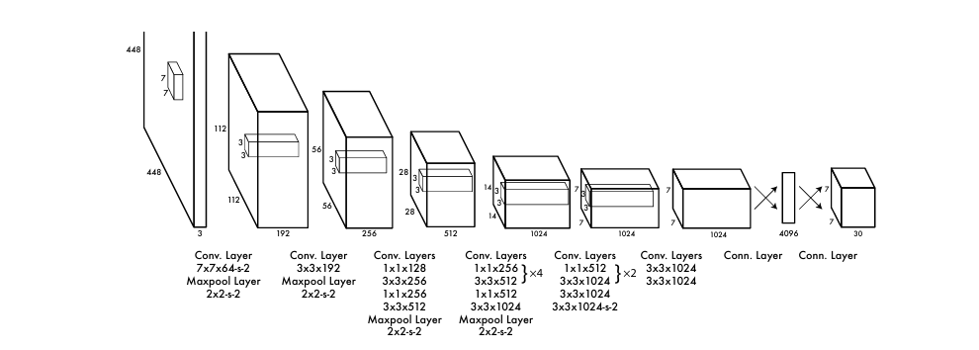
Fig.1.2.1 The Architecture of the YOLOV1[12]

YOLOV2[13]: The actual name of YOLOV2 is YOLO9000. It was launched one year after the release of YOLOV1. The launch of YOLO9000 was aimed at addressing the limitations of the object detection datasets at that time. The researchers behind YOLO9000 have proposed a unique joint training algorithm. This method utilizes labeled detection images to learn precise object localization, and uses classification images to enhance its robustness as shown in the Fig.1.2.2. Ultimately, YOLO9000 can detect over 9,000 different object categories, which is how it got its name. The picture on the right illustrates a technique employed by YOLOv2. YOLOv2 Combining datasets using WordTree hierarchy which are shown in the Fig1.2.2.

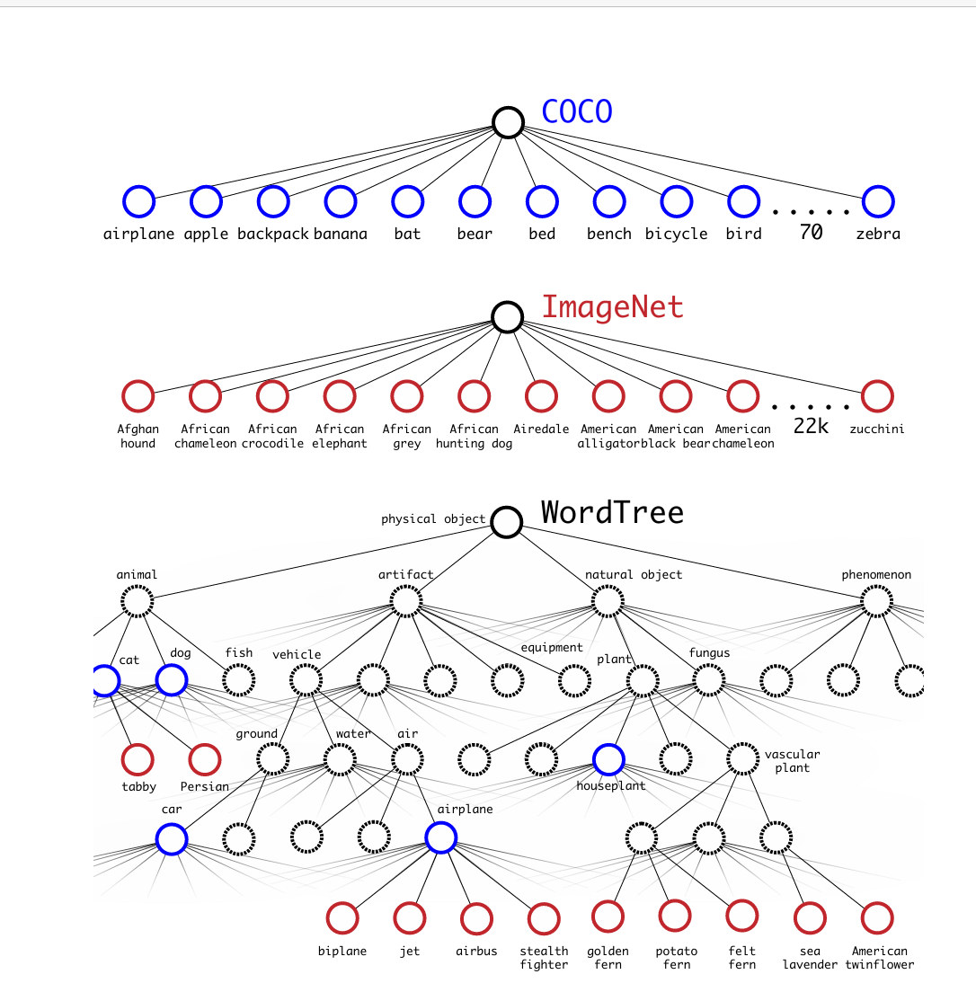

Fig.1.2.2 Combining datasets using WordTree hierarchy[13]

YOLOV3[14]: Although YOLO9000 is already quite advanced, it can still be optimized to improve its accuracy. YOLOV3 incorporates multi-scale prediction, which means it can extract feature maps from the original image at different scales and then predict the bounding boxes. With this improvement, YOLOV3 can detect objects of different sizes more effectively.

YOLOV4[15]: YOLOV4 incorporates a number of improvements, and its key innovations are mainly reflected in the architecture design and training methods. The most significant contribution of YOLOV4 in terms of architecture is the proposal of splitting the YOLO architecture. He divided YOLO into three parts: backbone, neck, and head as shown in the Fig.1.2.3.

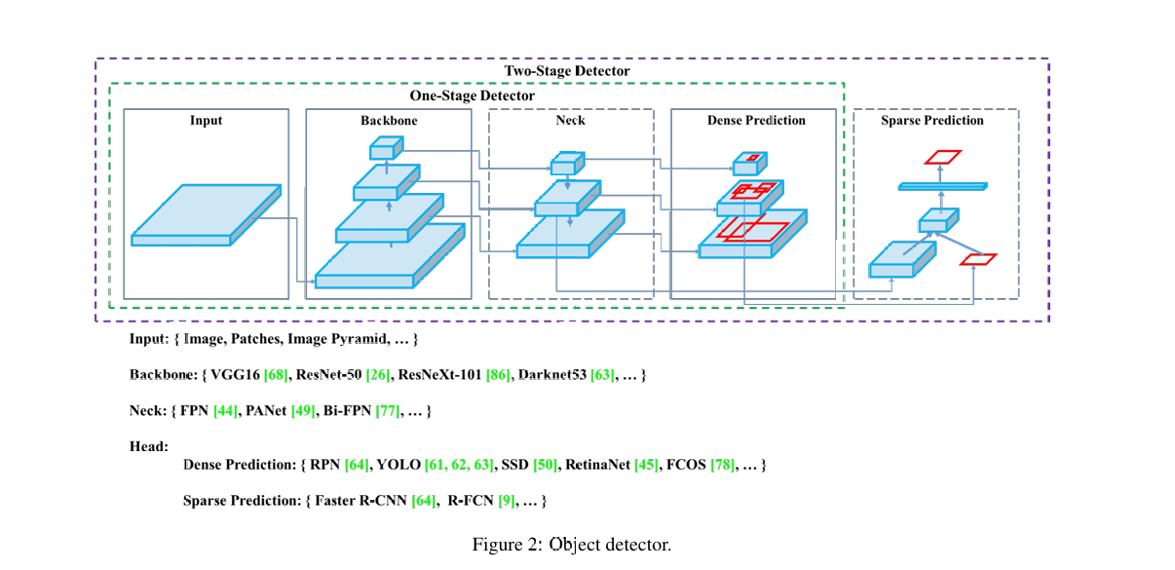

Fig.1.2.3 Object detector[15]

YOLOV5[16]: YOLOv5 has undergone multiple optimizations in terms of engineering practice, training efficiency, and ease of use. Compared with YOLOV4, YOLOV5 has optimized the usability of its framework. YOLOV5 is entirely based on PyTorch, making it more convenient for developers to quickly train and debug. The Focus module was introduced in the structure to replace some of the downsampling convolutions, thereby reducing the computational load. And the Cross Stage Partial structure has been optimized. By adopting the Path Aggregation Network structure, it enhances the ability of multi-scale feature fusion and improves the detection performance of small targets.

YOLOV6[17]: YOLOV6 represents a significant evolution within the YOLO series. Developed by Meituan, it incorporates several key architectural changes as shown in Fig.1.2.4, enabling the YOLO algorithm to achieve a better balance between speed and accuracy. YOLOV6 uses EfficientRep in its backbone to construct the main structure.

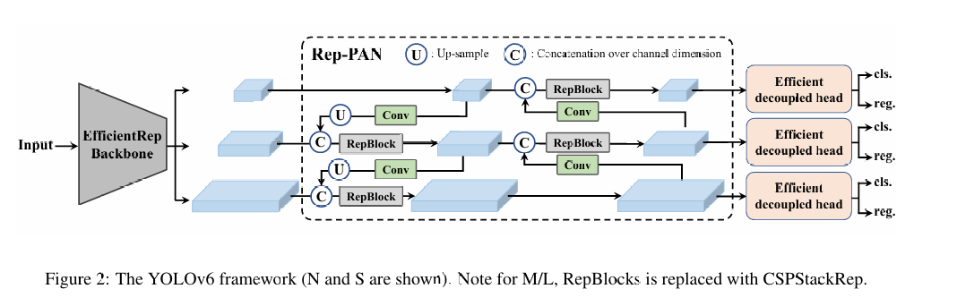
Fig.1.2.4 The YOLOV6 framework[17]

Neck layer employs the Rep-PAN topology and uses RepBlock to enhance the original PAN topology, which provides more efficient feature aggregation.Its head introduces the Efficient Decoupled Head, which adopts a mixed channel strategy to reduce the number of intermediate convolutional layers.

YOLOV7[18]: YOLOV7 introduces a novel concept called "Trainable bag-of-freebies". These improvements mainly focus on optimizing the training process. These improvements can enhance the model's ability to effectively represent information and will not significantly increase the computational cost. During the training process, it employed a self-distillation technique: to address the challenges of dense targets and model generalization.

YOLOV8[6]: YOLOV8 incorporates the experience of the previous YOLO algorithm and is also the main algorithm studied in this research. Developed by Ultralytics. It offers top-notch performance in terms of accuracy and speed. In the following part, we will provide a detailed description of the specific details of the YOLOV8 model used in this research.

Methodology and Results

Methodology

Data Preparation
Because the series of YOLO algorithms we use is a type of supervised learning algorithm[7]. This means that before we use this model, we must prepare the data sets, and these data sets must have been manually labeled in advance. Therefore, in the field of PCB defect detection, we must prepare the PCB defect data that has been meticulously reviewed by professionals. However, in reality, the types of PCB defects can be infinitely subdivided and have various different names. In order to facilitate the efficient advancement of the research, this paper will prepare six of the most frequent types of PCB defects to represent the defect of the PCB[19].
The dataset we used in the research is an open dataset from Roboflow Universe. This dataset contains approximately 690 images of PCB defects. We divided the dataset into training set, validation set and test set. We trained the model using the training set and focused on evaluating the performance of the test set under different model architectures for assessment. This dataset includes six common types of PCB defects that have all been labeled. The six types of defects are: 'missing hole'(Fig.2.1.1) , 'mouse bite' (Fig.2.1.2), 'open circuit' (Fig.2.1.3), 'short' (Fig.2.1.4), 'spurious copper' (Fig.2.1.5) and 'spur' (Fig.2.1.6).
'missing hole' means when a required hole is not drilled, which prevents proper electrical connections. A 'mouse bite' refers to small, irregular notches or damage along the edge of the board. An 'open circuit' is a break in a conductive path, stopping electricity from flowing where it should. Conversely, a 'short' is an unintended connection between two conductive paths that should be separate. 'Spurious copper' is the leftover copper that wasn't properly etched away. Lastly, a 'spur' is a small, sharp, and unwanted piece of metal sticking out from a copper trace.

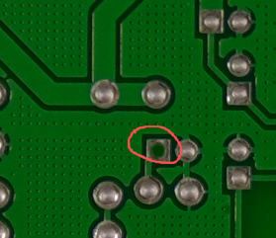
Fig.2.1.1 Missing hole

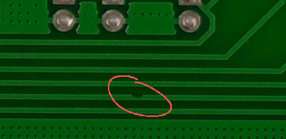
Fig.2.1.2 mouse bite

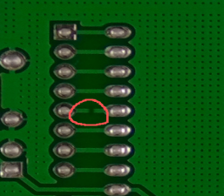

Fig.2.1.3 Open circuit

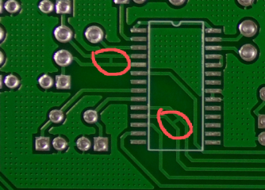
Fig.2.1.4 Short

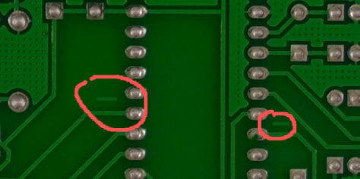
Fig.2.1.5 spurious copper

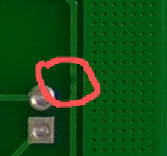
Fig.2.1.6 spur

2.1.2 YOLO v8
The model we use for detecting defects on PCB is called YOLOv8[6]. The YOLO v8 was launched by Ultralytics. It is an optimized version based on the previous algorithm series of YOLO. This algorithm strikes a relatively balanced trade-off between accuracy and inference speed. Compared with the earlier versions of YOLO, YOLOv8 has optimized the architecture and modules, aiming to provide a more efficient and versatile model.
YOLOv8 can be regarded as consisting of three important components, namely backbone, neck, and Head as shown in Fig.2.1.7 The essence of the backbone can actually be regarded as an improved version of the convolutional neural network (CNN). The backbone has the ability to extra multi-scale features from the original images. This means that YOLO v8 can capture features at different resolution levels. With the extraction of these multi-dimensional features, YOLOv8 can effectively connect the textures of the image with our high-level semantic information, thereby completing our defect recognition task.
Neck: The "neck" module in YOLOV8 is used to integrate and refine the features extracted by the backbone layer. The original version of YOLOV8 uses a neck that is called Path Aggregation Network (PANet). In the following part, we will introduce the optimizations we have made to the "neck" layer in this article, with the aim of enhancing the model's ability to select and integrate features of different scales.
Neck: The "neck" module in YOLOV8 is used to integrate and refine the features extracted by the backbone layer. The original version of YOLOV8 uses a neck that is called Path Aggregation Network (PANet). In the following part, we will introduce the optimizations we have made to the "neck" layer in this article, with the aim of enhancing the model's ability to select and integrate features of different scales.

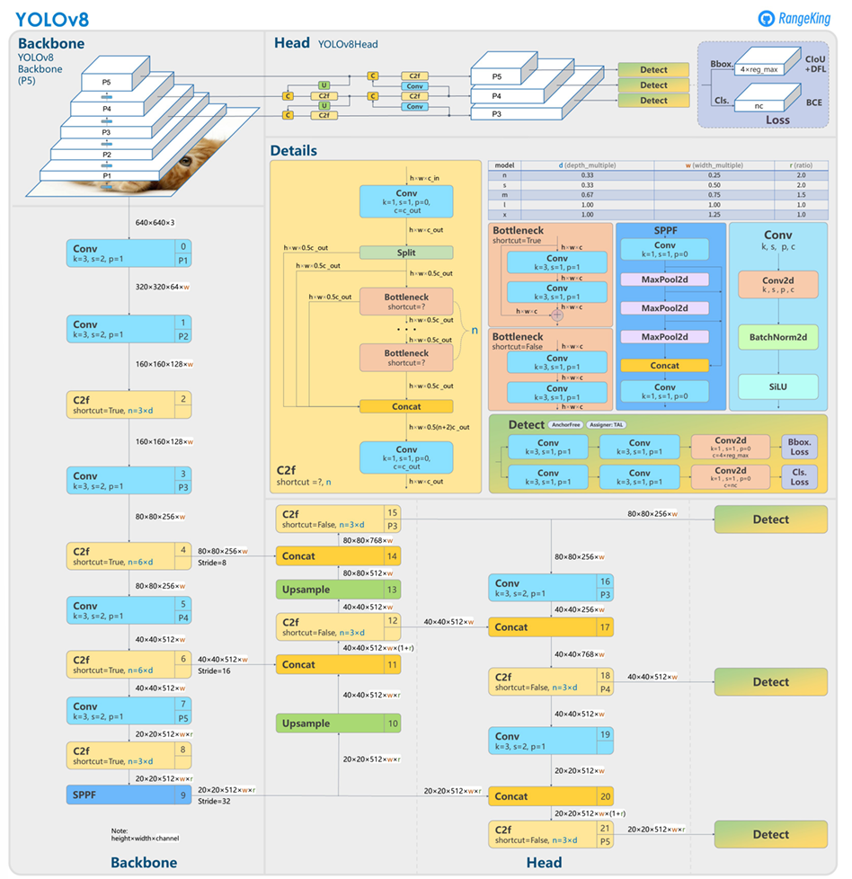
Fig.2.1.7 Model Structure of YOLOv8[21]

YOLOv8 has many versions, such as YOLOv8n,YOLOv8s,YOLOv8m,YOLOv8l. They are structurally and algorithmically similar. Among these different versions YOLOv8n has the smallest number of parameters. It just has 3157200 parameters which is much smaller than other version of YOLOv8. The smaller parameter quantity enables the YOLOv8n to be applicable for localized training and deployment, and while maintaining a relatively high accuracy, it speeds up the training and inference processes, making it the fundamental model for the PCB defect detection research in this paper. The model architecture of YOLOv8n used in this research is exactly as depicted in the Fig.2.1.8.This YOLOv8n follows the basic framework of YOLOv8.We can observe that the input on the far left is sent to the backbone for feature extraction.We can observe that through the cooperation of multiple convolutional layers and the C2f layer, features are continuously extracted. As we move towards deeper layers of the backbone, the scale of feature extraction also becomes deeper. A total of three different-depth feature representations will enter the "neck" layer. In the "lack" layer, the model performs the process of mixing and refining the features. After continuous integration, they will output the final result from the "head" layer. P3, P4, and P5 represent the final determination results of different depth features. These results will ultimately determine the model's final judgment on the image.
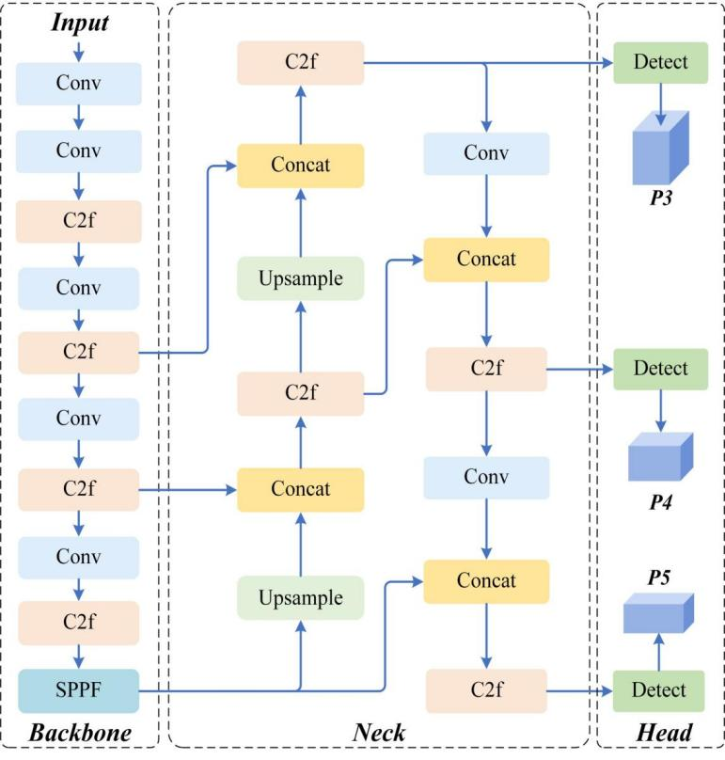
Fig.2.1.8 YOLO v8n

2.1.3 Transfer Learning
In the field of deep learning, transfer learning[8] is a widely adopted technical approach. Transfer learning is not a specific method, but rather a working paradigm. Its core idea is a machine learning technique that applies a pre-trained model (the source model) to new tasks. In this way, the general features learned by the source model from a large amount of data can be transferred and applied to the training of new tasks, thereby improving the performance of the model.Appropriate utilization of transfer learning can significantly reduce our training time, as the source model already contains a large amount of basic knowledge, thus reducing the training time for the target task. Transfer learning can also reduce the amount of data required for new tasks. This feature directly addresses one of the core issues in our PCB defect detection, which is the lack of PCB data.
Our idea in this research is to find an initial model that has been trained on a large dataset, and then fine-tune it based on a small-scale PCB defect dataset to achieve the desired result. In this study, we selected a YOLOv8 model that underwent large-scale pre-training on the COCO dataset[21] as our source model. The COCO dataset as shown in Fig.2.1.9 is a large-scale dataset used for image recognition, containing 330,000 images each annotated with 80 object categories. The COCO dataset is widely applied in the field of computer vision research.
The basic strategy we employ for transfer learning is as follows: we use YOLOV8n as the framework and adopt the pre-trained weights from the COCO dataset as the initial values.We adopt a progressive training strategy, that is, at the beginning, we freeze the backbone network and only train the head layer. When the training reaches a certain stage, we gradually unfreeze the backbone layers of the model. In the subsequent discussion of the experimental results, we will compare the capabilities of two YOLO algorithms (one using transfer learning and the other without using transfer learning) in the PCB defect detection task.
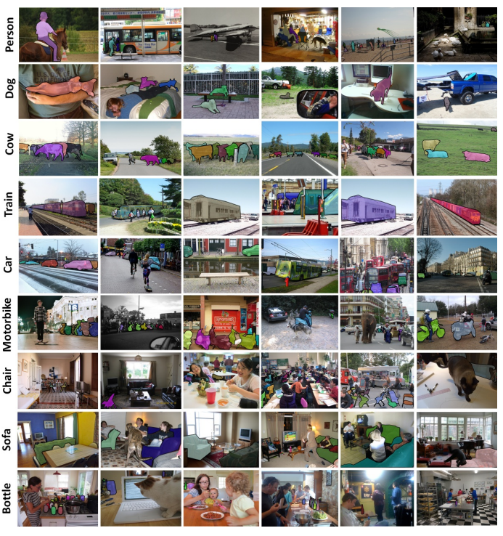
Fig.2.1.9 Samples of images in COCO dataset[21]

2.1.4 Bidirectional Feature Pyramid Network
As we previously described, YOLOv8 can be regarded as consisting of three main parts, among which the neck part is specifically designed for integrating features.In this study, we made an innovation to the neck part of the standard YOLOV8 model, replacing its original PANet structure with the BiFPN(Bidirectional Feature Pyramid Network) structure[9]. With this change, we expect to enhance the model's ability to integrate features by increasing its differentiated learning of features at different scales which is expected to improve the model's accuracy in detecting PCB surface defects.

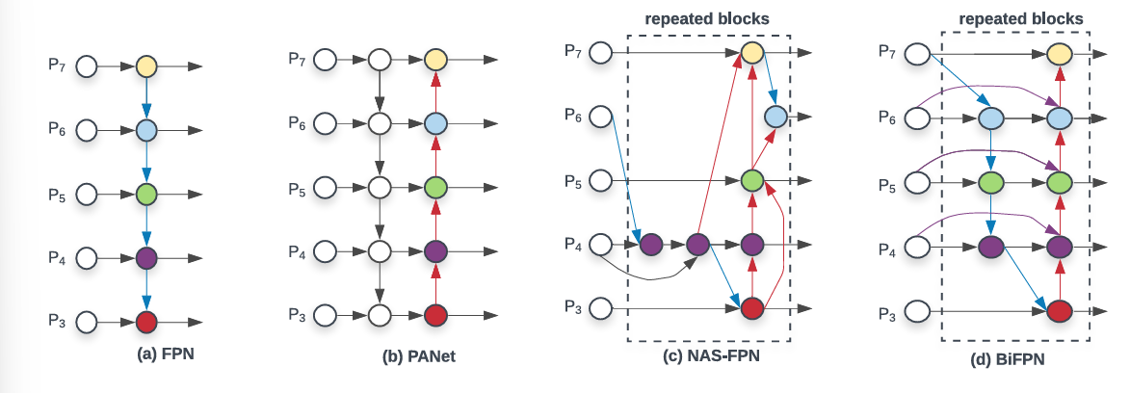
Fig.2.1.10 Feature network design[9]

As shown in Fig.2.1.7, the Neck structure used in the initial model of YOLOv8 is actually the (b) PANet in Fig.2.1.10 PANet is actually an improved version based on FPN as shown in Fig.2.1.10(a). Comparing to FPN, PANet adds an extra bottom-up path aggregation network. The mechanism of FPN can be simply expressed in a mathematical formula. As shown in Fig.2.1.10(a), it tasks level 3-7 input features 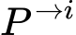 = (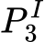, ...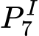), where 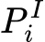represents a feature with resolution of 1/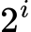 of the original input images. FPN integrates features of different scales in the following manner:
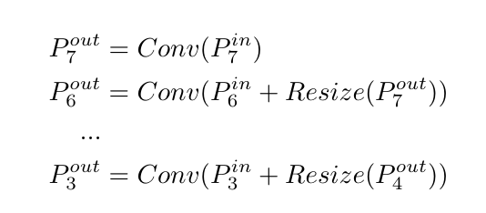

In the situation shown in the Fig.2.1.11, Resize represents an up-sampling or down-sampling operation, while Conv represents a convolution operation for processing features.
A detailed explanation of FPN is helpful for understanding the mechanism of BiFPN, because they are similar in the microscopic operations, and the main difference between them lies in their macroscopic architecture. PANet is an optimized version of FPN and BiFPN is an optimization of the neck network based on PANet. Comparing with PANet, first, BiFPN removes the nodes that have only one input edge. This simplifies the structure of the network by eliminating these nodes that have a low contribution to feature fusion. This operation’s impact on the model's feature fusion is minimal, but it effectively improves the training efficiency of the network. Secondly, BiFPN adds an extra edge to connect the initial input to the output node. This helps to integrate more features while maintaining low consumption. Finally, unlike PANet which merely consists of a top-down and one bottom-up path, BiFPN repeatedly utilizes multiple top-down paths and bottom-up paths. BiFPN treated one top-down and bottom-up path as one feature network layer. In this way, BiFPN gain the ability to promote higher-level feature fusion.

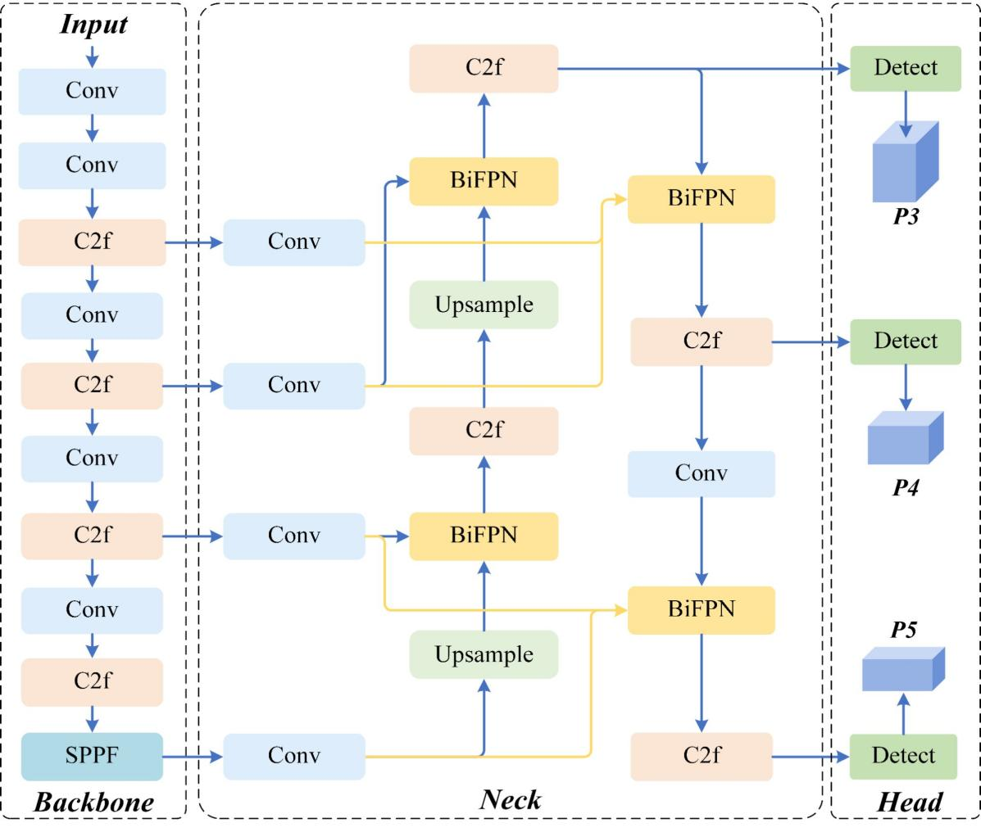
Fig.2.1.11 The structure of BiFPN enhanced YOLOv8n

2.1.5 Adaptive Fine-Grained Channel Attention
Adaptive Fine-Grained Channel attention is also referred to as AFGC attention module[22]. As shown in the Fig.2.1.12, We added this module at the connection edge between the SPPF in the backbone and the neck network. In this way, we expect to refine the deep semantic features in the SPPF(Spatial Pyramid Pooling-Fast) once before performing multi-scale fusion in the neck network.

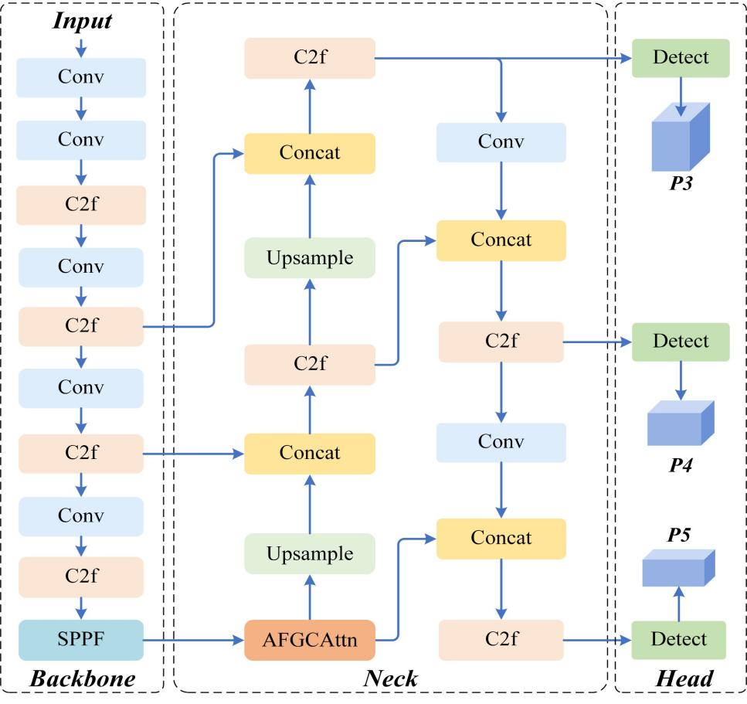
Fig.2.1.12 The structure of AFGCattention enhanced YOLOv8n

The SPPF is a kind of module that implements a multi-scale pooling strategy. This module can efficiently integrate features from different scales. However, due to the inherent limitations of this module, when integrating features, it will contain a lot of irrelevant or unimportant information, which will affect the subsequent fusion of features by the Neck. Therefore, it is necessary to conduct a screening on the high-depth semantic features obtained by SPPF. AFGC Attention model can dynamically adjust the weights of different feature channels obtained from SPPF. This modification can enable the model to select more important features and reduce the noise in the background.
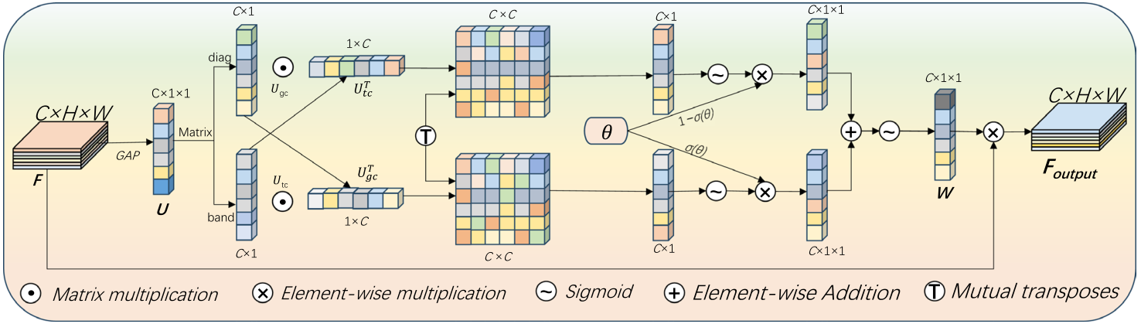

Fig.2.1.13 Architecture of AFGC module[22]

As shown in the mechanism diagram presented in Fig.2.1.13, first the feature map is reshaped from a C * H * W dimension to a C * 1 * 1 format by a function called GAP(Global Average pooling). Then we get a global descriptor named U. This operation integrates global contextual information, making it possible to combine the scattered presentations from small targets, while maintaining the integrity of global information. Secondly, 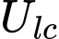 and 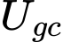 respectively represent the interval matrix and the diagonal matrix and are used to extract and calculate local information. These components can capture the fine-grained local details of small targets such as some small defects in the PCB. Then, the small details are fused with the global semantic context. In this way, the small-target features’ representational power can be enhanced. The AFGC attention module also implements an adaptive fusion mechanism. When the detected feature maps has a complex background, It reduces the influence of those related channels that contain irrelevant information, and selectively selects those feature channels that are representative of details. With the operations of element-wise multiplication and learn-able weight W, This module dynamically filters features in order to enhance the recognition ability for the following small targets and reduced the negative impact of the background. Overall, this module aligns with our core demands of find the small target as the PCB defect. In the base version of YOLOv8n, we have incorporated this module. Based on its principle, we hope to enhance the sensitivity of our model in the process of integrating features, so as to improve its ability to detect some fine features on the PCB surface.

Results

Experimental Configuration
All the experiments in this study were conducted under the same environment, as shown in Table 2.2.1. These parameters provide a detailed description of the specific situations of the implementation environment. We mainly use NVIDIA's GPU and combine it with the deep learning framework of PyTorch to train the model. This is a mainstream deep learning configuration.

type | parameter
GPU | NVIDIA GeForce RTX4070
operating system | Windows
memory | 12GB
Python version | 2.8
Torch version | 1.9
development environment | pycharm

Table.2.2.1 experimental environment

Experimental parameter configuration
To ensure the fairness of the experiments, we kept the training parameters for all models consistent. The total number of training epochs is set to 100. The training device is selected as GPU. The batch size is set to 16. The optimizer used for training is SGD. The size of the input images is 640*640. The number of workers is set to 0.

Experimental evaluation indicators

2.2.3.1 Mean Average Precision
The experiment mainly utilized the mAP(Mean Average Precision)[23] and confusion matrix[24] to evaluate the performance of the model.
Firstly, mAP(Mean Average Precision) is a commonly used evaluation metric in the task of object detection, which can effectively measure the performance of the model after data training. Before understanding the principle of mAP, it is necessary to have a thorough understanding of AP (average precision).
Precision: precision means that Among all the samples classified as positive examples (positive category), the proportion of true positive cases (those actually belonging to the positive category). From another perspective, this indicator measures the risk that the classifier mistakenly classifies negative examples (negative categories) as positive examples. The formula for calculating the precision is: Precision = True Positives / (True Positives + False Positives). We can also express its meaning with a simplified formula:
P = TP / (TP + FP). In this formula, p represents precision. TP stands for "True Positive", which means that the predicted result is a positive example and the actual result is also a positive example. In our PCB defect detection task, TP stands for the situation where our model correctly identifies the classification of a defect. FP indicates that the model's prediction result is a negative example, while the actual result is a positive example, and the prediction is incorrect. This often indicates that our model has failed to detect some actual PCB defects that exist.
Recall: Recall means the proportion of all actual positive samples that are successfully classified as positive. it evaluated the classifier's ability to accurately detect positive cases, just as in our task it meant finding out how many defects we had identified among all the actual defects present on the PCB. The formula for calculating the Recall is shown as: Recall = True Positives / (True Positives + False Negative). We also usually represent its meaning with a simple formula: R = TP / (TP + FN). Here, TP has the same definition as TP in the precision. FN stands for "False Negative". It represents the situation where the predicted result is a negative case, the true result is also a negative case, and the prediction is correct. In our PCB defect detection task, this means that we did not mistakenly classify the normal parts of the PCB as a type of defect that is irrelevant to them.
AP (average precision): The target detection task all has a confidence score[]: it is the probability predicted by a classifier that an anchor box contains a certain object. Setting the Confidence Threshold allows you to filter out the predicted objects that are smaller than the threshold. By changing different confidence threshold values, multiple pairs of Precision and Recall values can be obtained. Place the Recall values on the X-axis and the Precision values on the Y-axis, and a Precision-Recall curve[7] can be drawn.
Based on the Precision-Recall curve, by calculating the average value of the Precision corresponding to each Recall value, AP (average precision) can be obtained.
mAP(Mean Average Precision): It involves calculating the AP for all categories and then taking the average. mAP measures the performance of the trained model in terms of its detection capabilities across all categories. If there are N defects in our PCB that need to be classified, then the calculation method of MAP is as follows.
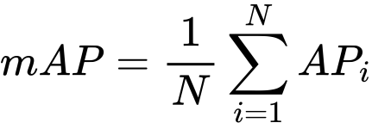

There are various calculation standards for mAP. In this article, we will discuss the most well-known map50 and map50-95, which are used to evaluate the models.
mAP50: The average precision value calculated when IoU=0.5. IoU (Intersection of Union): It is an indicator used in object detection to measure the degree of overlap between the predicted bounding box and the actual bounding box. IoU=0.5 indicating that as long as the overlap between the predicted box and the real box reaches 50%, it can be considered that the detection is correct.
mAP50-95: This refers to calculating the average precision of the model across multiple different IoU thresholds (typically ranging from 0.5 to 0.95 with a step size of 0.05), and then averaging these precisions. Overall, as the IOU increases, the model's discrimination criteria become stricter.

2.2.3.2 Confusion Matrix
The confusion matrix is an important tool in machine learning for evaluating the performance of classification models. Through the confusion matrix, one can visually understand the performance of the model in each category.
The confusion matrix is generally composed of a two-dimensional table. Each row of the table represents the prediction situation of each class. For example, if the header of each row in the table represents the true class, then the header of each column in the table represents the predicted class.I have drawn an abstract logic diagram below:

Confusion  Matrix |  | Prediction Category
True  Category |  | Category1 | Category2
 | Category1
 | Category 2

Table.2.2.2 Confusion Matrix Example

Just as the example of a confusion matrix shown in Table.2.2.2 demonstrates, a confusion matrix is a two-dimensional matrix. One axis of the matrix represents the true category of the identified object, which is the label behind the data, while the other axis represents the predicted result. The value at each intersection of the x-axis and y-axis measures the true category of that value and how the model predicts it.

Experimental Result
We have a total of five groups control experiments. The first one is the original version of YOLOv8n, and the second one is is YOLOV8n with transfer learning. The third type is BiFPN enhanced YOLOV8n. The fourth type is YOLOV8n that integrates the AFGC attention. The fifth type is YOLOV8n Concurrently perform optimization of BiFPN and AFGC attention. The Results in Table.2.2.3 is in the test dataset.

Models | mAP50 | mAP50-95
YOLOV8n | 0.884 | 0.431
YOLOV8n(Transfered) | 0.891 | 0.432
YOLOV8n + BiFPN | 0.895 | 0.44
YOLOV8n + AFGC | 0.90 | 0.45
YOLOv8n+BiFPN+AFGC | 0.94 | 0.491

Table.2.2.3 The map results of the control experiment

Firstly, it is clearly observable that there is not a significant difference in mAP between the initial version of YOLOV8n and the one that has utilized transfer learning. The mAP50 seems to have improved slightly, but in the more stringent map50-95 measurement dimension, there is no significant improvement in the performance by implementing transfer learning. Obviously, this is related to the training data of the source model we chose for the transfer learning. Since the source model we used was trained based on the COCO dataset, and there is not much content related to our specific task of PCB defect detection in the COCO data. Although the current transfer learning did not significantly improve the performance of the model, it was still a beneficial attempt.
Secondly, it is quite obvious that the second and third groups of experiments have significantly improved the standard version. When the basic YOLOV8n was equipped with the BiFPN module, The value of map50 has significantly increased by 0.1. The value of map50-95 has also increased by 0.1. This proves exactly as we previously hypothesized that the BiFPN will enhance the model's ability to detect defects, and it is a neck network that is superior to the original version of PANet. After adding the AFGC module, we achieved better results. Both Map50 and Map50-95 have shown significant improvements.
Finally, we applied both optimization methods to our model simultaneously, as they serve different purposes: one for optimizing the architecture of the neck model, and the other for connecting the backbone and neck layers. There is no conflict between them. After implementing both optimization, our model achieved the best performance. The map50 metric reached 0.94, and the map50-95 metric also reached 0.491. This proves that the application of two optimization methods at the same time is feasible, and it can enhance the model's ability to identify defects in PCB.
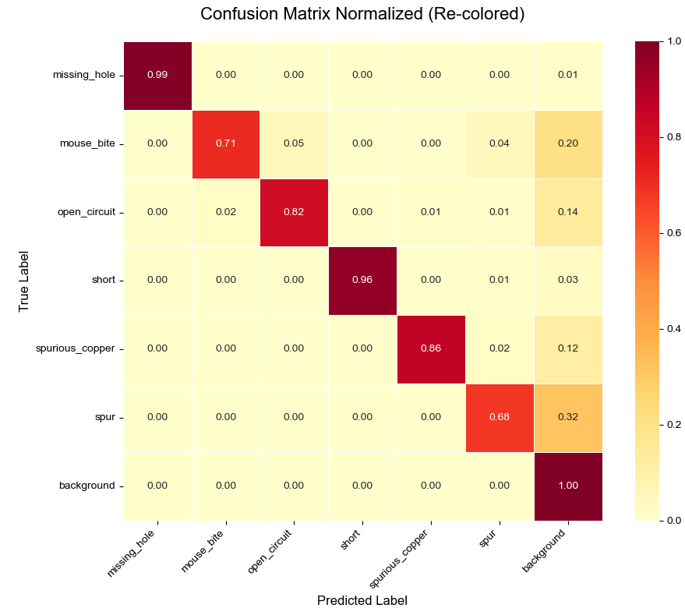
Fig.2.2.1 Confusion matrix of YOLOV8n

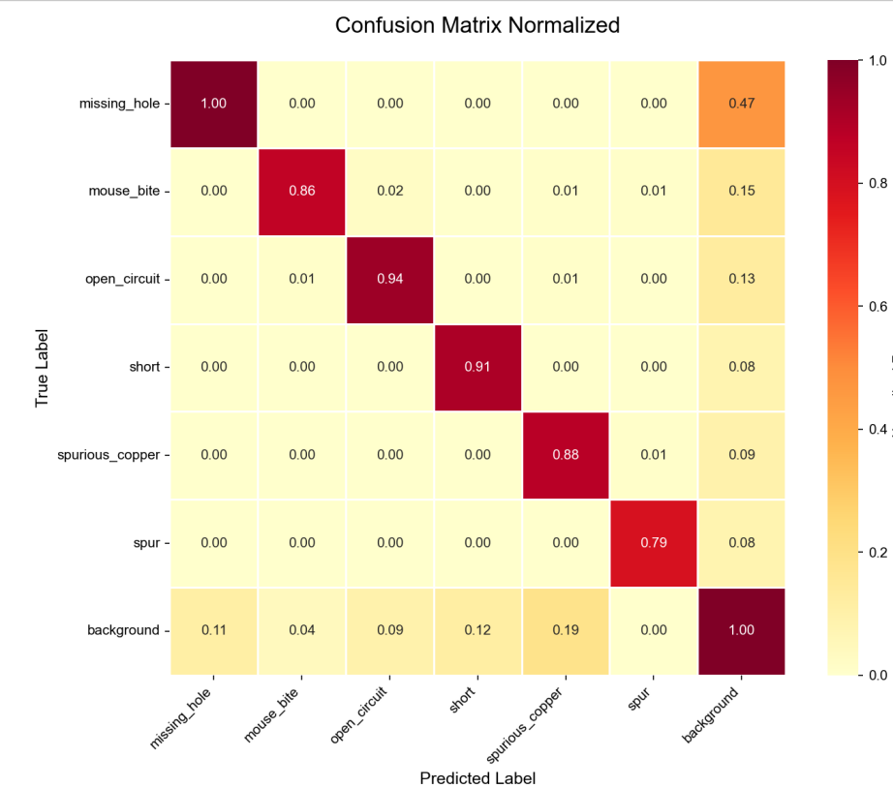
Fig.2.2.2 Confusion matrix of YOLOV8n+BiFPN +AFGC

The above are the confusion matrices of the initial version of YOLOV8n in Fig.2.2.1, as well as the YOLOV8n that have been optimized with BiFPN and AFGC attention in Fig.2.2.2. The numbers on the diagonal of the confusion matrix clearly show the recognition performance of each category model before and after optimization. For each value in the matrix, we have performed normalization to facilitate comparison. The value on the diagonal corresponding to a particular category is larger, the higher the recognition rate of the defect for that category.
We can observe that the recognition of missing_hole shows no significant difference between the two methods. Both are close to a complete recognition. This might be because the image features of missing_hole are relatively distinct and thus easier to identify. On the contrary, the detection rate of the PCB defects in the "mouse_bite" category has significantly increased after the introduction of the BiFPN and AFGC attention mechanisms. "Mouse_bite" is a minor defect category. The increase in the detection rate of this category fully demonstrates the enhanced recognition ability of our model after optimization, which can identify more detailed defects on PCB.
Overall, the optimization of BiFPN and the introduction of the AFGC attention mechanism in this study have significantly enhanced the model's ability to detect six types of PCB defects, which fully validates the effectiveness of our research.

Conclusion and Future Work

Conclusion
In a conclusion, we have developed a YOLO series algorithm called YOLOV8 detect defects on PCB. Due to the scarcity of high-quality PCB data in reality, the research in this paper is conducted by training and optimizing the model based on a small sample dataset. We attempted to apply the transfer learning technique to transfer the YOLO model that had been trained on the COCO dataset to complete our downstream PCB defect detection task. Although the final result was not satisfactory due to the mismatch between the training data of the source model and the target task, it was still a beneficial exploration. In addition, we also attempted to optimize the basic model of YOLOV8. On one hand, we optimized the neck layer of YOLOV8, converting it from the traditional PAnet version to the more flexible BiFPN. On the other hand, we introduced the AFGC attention mechanism at the connection point between the SPPF layer of YOLOV8 and the Neck layer. These optimizations ultimately led to the results we desired, improving the mAP of PCB defect detection.

Future Work
In the future, there are still some directions that we can explore to further unlock the potential of this method. On the one hand, we can look for more appropriate source models to ensure that our transfer learning can truly achieve the desired results. To complete this task, it is essential to ensure that the training data of the source model closely matches the data of our PCB defect detection task. Another point is that this paper focuses solely on optimizing the Neck and backbone of the model. However, there are many other ways to optimize the model that can also be attempted. For instance, there are some optimization methods that can be explored for the head layer of the model, or at the connection point between the head and the Neck layers. These possible directions all deserve rigorous analysis, argumentation.

References
- LaDou, J. (2006). Printed circuit board industry. International journal of hygiene and environmental health, 209(3), 211-219.
- Singh, K., Kharche, S., Chauhan, A., & Salvi, P. (2024). PCB Defect Detection Methods: A Review of Existing Methods and Potential Enhancements. Journal of Engineering Science & Technology Review, 17(1).
- Liao, H. C., Lim, Z. Y., Hu, Y. X., & Tseng, H. W. (2018, July). Guidelines of automated optical inspection (AOI) system development. In 2018 IEEE 3rd International Conference on Signal and Image Processing (ICSIP) (pp. 362-366). IEEE.
- Li, Z., Liu, F., Yang, W., Peng, S., & Zhou, J. (2021). A survey of convolutional neural networks: analysis, applications, and prospects. IEEE transactions on neural networks and learning systems, 33(12), 6999-7019.
- Jiang, P., Ergu, D., Liu, F., Cai, Y., & Ma, B. (2022). A Review of Yolo algorithm developments. Procedia computer science, 199, 1066-1073.
- Sohan, M., Sai Ram, T., & Rami Reddy, C. V. (2024). A review on yolov8 and its advancements. In International conference on data intelligence and cognitive informatics (pp. 529-545). Springer, Singapore.
- Cunningham, P., Cord, M., & Delany, S. J. (2008). Supervised learning. In Machine learning techniques for multimedia: case studies on organization and retrieval (pp. 21-49). Berlin, Heidelberg: Springer Berlin Heidelberg.
- Weiss, K., Khoshgoftaar, T. M., & Wang, D. (2016). A survey of transfer learning. Journal of Big data, 3(1), 9.
- Tan, M., Pang, R., & Le, Q. V. (2020). Efficientdet: Scalable and efficient object detection. In Proceedings of the IEEE/CVF conference on computer vision and pattern recognition (pp. 10781-10790).
- Sun, H., Wen, Y., Feng, H., Zheng, Y., Mei, Q., Ren, D., & Yu, M. (2024). Unsupervised bidirectional contrastive reconstruction and adaptive fine-grained channel attention networks for image dehazing. Neural Networks, 176, 106314.
- Zhao, Z. Q., Zheng, P., Xu, S. T., & Wu, X. (2019). Object detection with deep learning: A review. IEEE transactions on neural networks and learning systems, 30(11), 3212-3232.
- Redmon, J., Divvala, S., Girshick, R., & Farhadi, A. (2016). You only look once: Unified, real-time object detection. In Proceedings of the IEEE conference on computer vision and pattern recognition (pp. 779-788).
- Redmon, J., & Farhadi, A. (2017). YOLO9000: better, faster, stronger. In Proceedings of the IEEE conference on computer vision and pattern recognition (pp. 7263-7271).
- Redmon, J., & Farhadi, A. (2018). Yolov3: An incremental improvement. arXiv preprint arXiv:1804.02767.
- Bochkovskiy, A., Wang, C. Y., & Liao, H. Y. M. (2020). Yolov4: Optimal speed and accuracy of object detection. arXiv preprint arXiv:2004.10934.
- Jaiswal, S. K., & Agrawal, R. (2024). A comprehensive review of YOLOv5: advances in real-time object detection. International Journal of Innovative Research in Computer Science and Technology, 12(3), 75-80.
- Li, C., Li, L., Jiang, H., Weng, K., Geng, Y., Li, L., ... & Wei, X. (2022). YOLOv6: A single-stage object detection framework for industrial applications. arXiv preprint arXiv:2209.02976.
- Wang, C. Y., Bochkovskiy, A., & Liao, H. Y. M. (2023). YOLOv7: Trainable bag-of-freebies sets new state-of-the-art for real-time object detectors. In Proceedings of the IEEE/CVF conference on computer vision and pattern recognition (pp. 7464-7475).
- Huang, W., & Wei, P. (2019). A PCB dataset for defects detection and classification. arXiv preprint arXiv:1901.08204.
- Hussain, M., Nadeem, M. A., & Khan, A. M. (2024). YOLOv8: an in-depth exploration of the internal features of the next-generation object detector. arXiv preprint arXiv:2408.15857.
- Lin, T. Y., Maire, M., Belongie, S., Hays, J., Perona, P., Ramanan, D., ... & Zitnick, C. L. (2014, September). Microsoft coco: Common objects in context. In European conference on computer vision (pp. 740-755). Cham: Springer International Publishing.
- Yang, J., Zhang, H., Zhang, W., & Ren, J. (2025). Awcf-yolo11: hierarchical attention fusion and adaptive channel refinement for object detection in remote sensing imagery. Multimedia Systems, 31(6), 1-20.
- Zhu, M. (2004). Recall, precision and average precision. Department of Statistics and Actuarial Science, University of Waterloo, Waterloo, 2(30), 6.
- Liang, J. (2022). Confusion matrix: Machine learning. POGIL Activity Clearinghouse, 3(4).

